Two Cascaded Common Emitter Stages

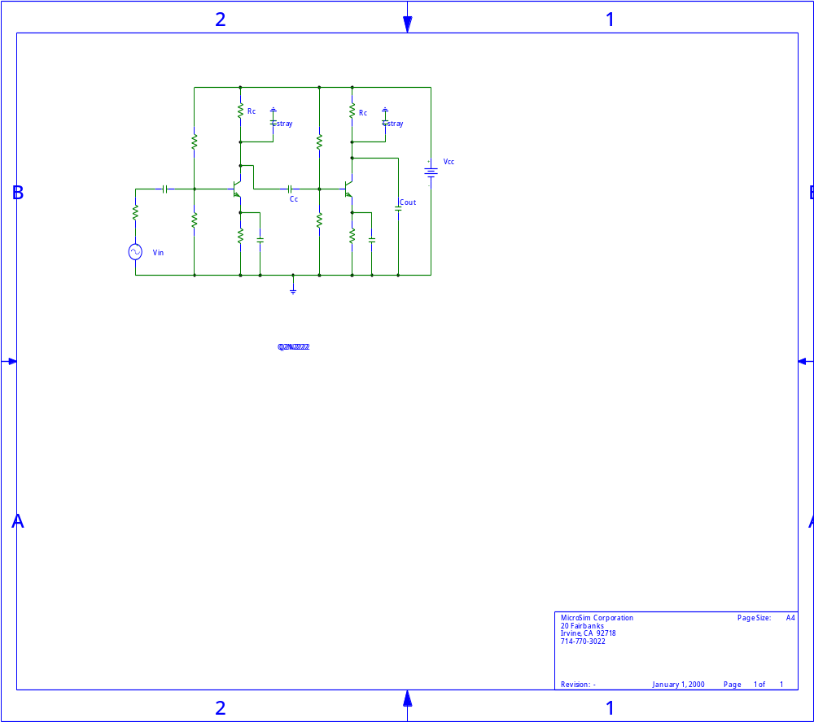

A.C. Equivalent Circuit
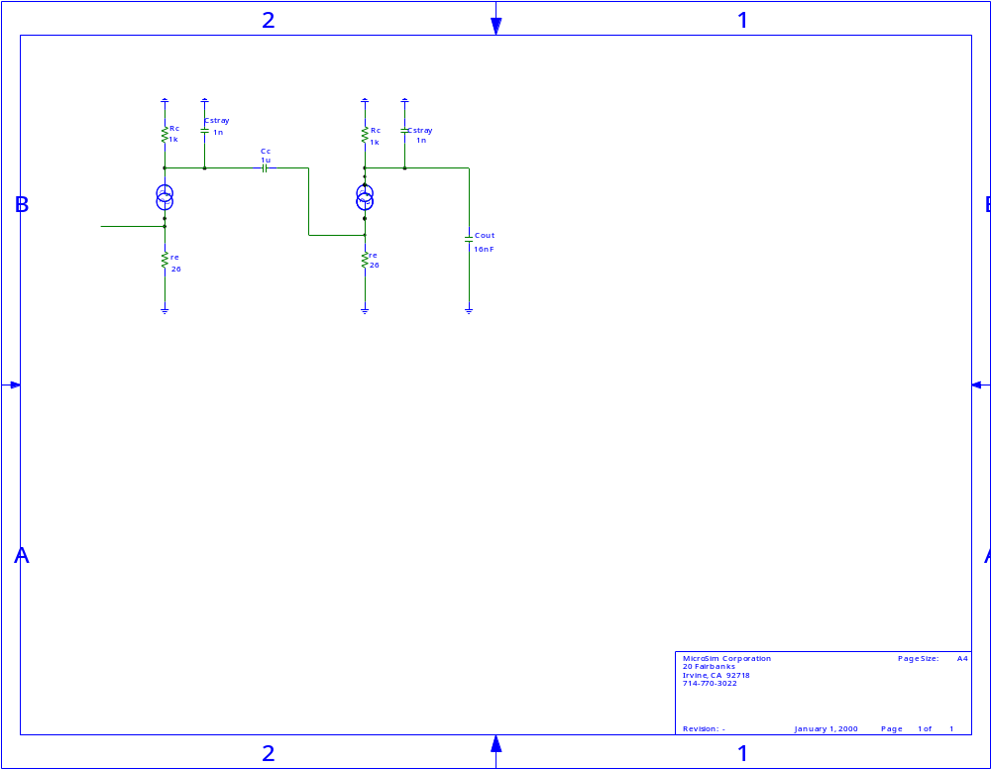

A.C. Equivalent Circuit Revised

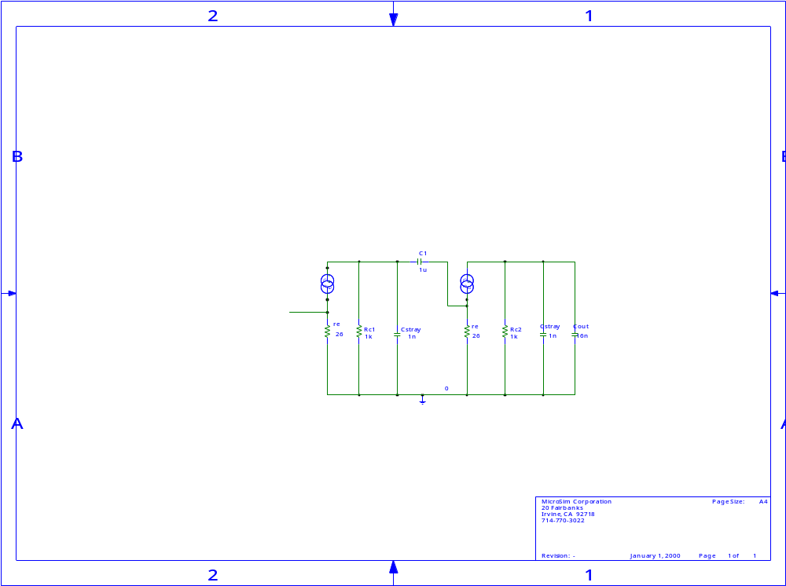

A.C. Revision Step2

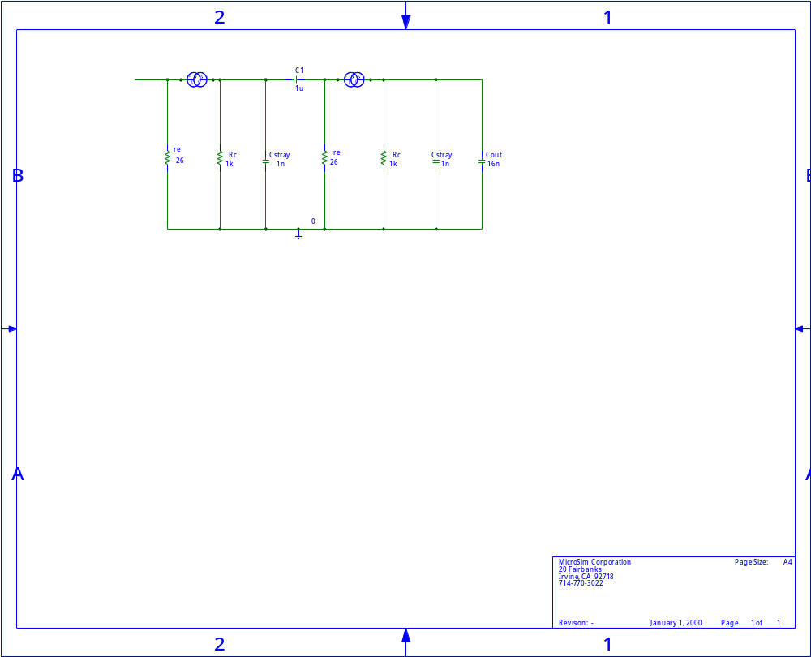

Stage 1 of the Cascaded Common Emitter

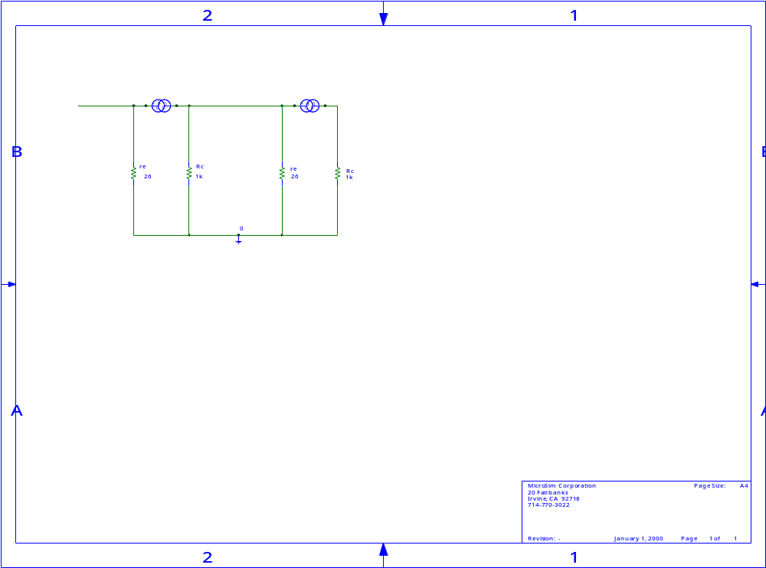

Because the value to be calculated is the maximum gain, maximum gain of the circuit is achieved when the reactance’s of the capacitors do not have an effect on the circuit. So emitting the capacitors simplifies the circuit analysis, but is required to relate the maximum output voltage when an input voltage is supplied.
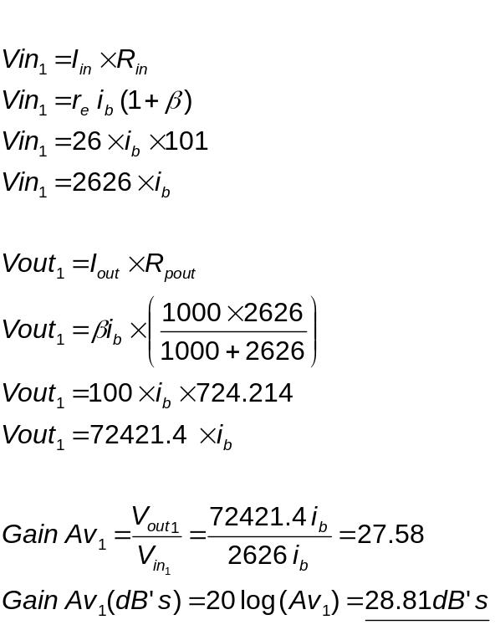
Stage 2 of the Cascaded Common Emitter

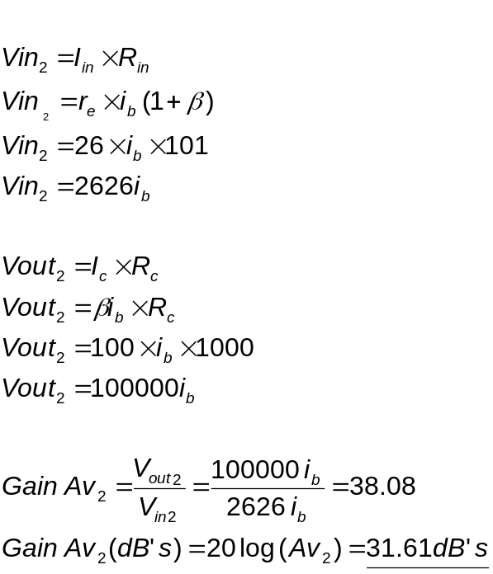

Total Gain of the system
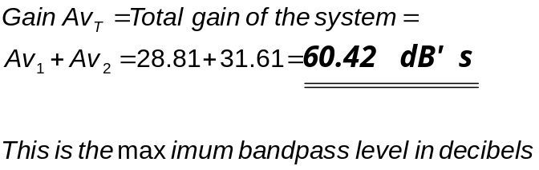

The lower cut off frequency (governed by C_{c} the coupling capacitor)

At low frequencies the capacitive reactance’s contained within the circuit are very high. It can be said that the stray capacitance C_{stray} and C_{o} have no effect on the frequency response of the amplifier at these low levels so are emitted in this particular case.
This means the coupling capacitor C_{c} is just in series with the output and input impedance.
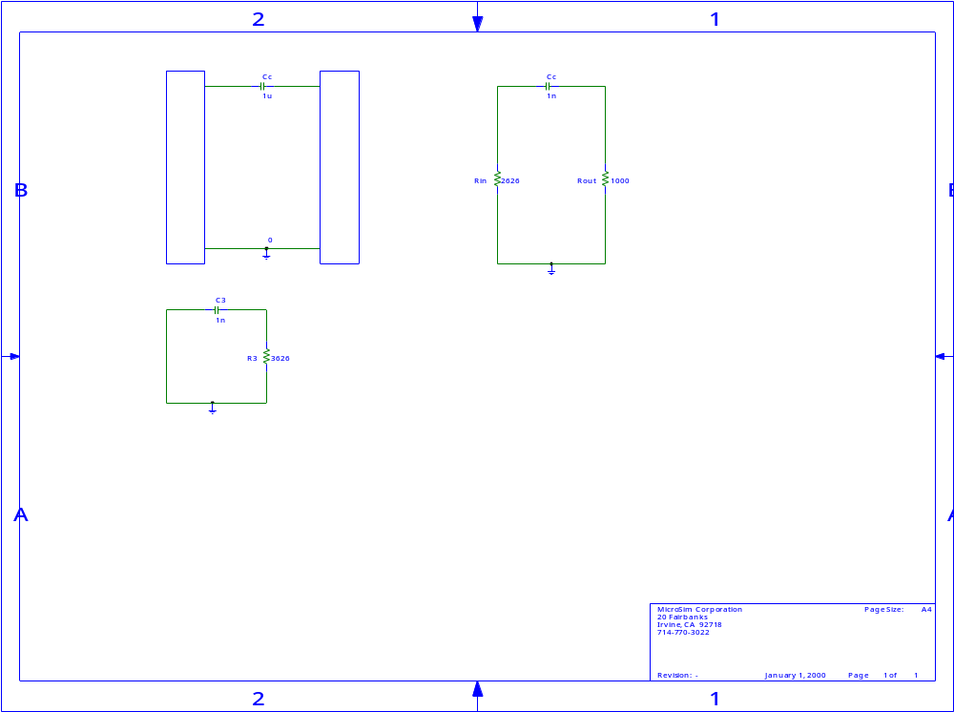

For any linear circuit the cut off frequency can be calculated using the equation below. However the circuit must be a Thevinin derived circuit i.e. an impedance in series with a voltage source.

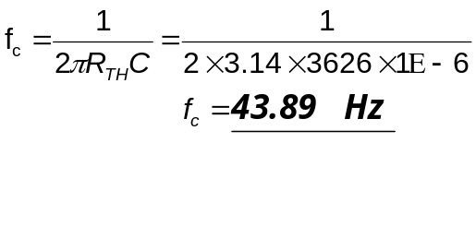

The upper cut off frequency (governed by C_{stray} and C_{o})

When high frequencies are applied to the circuit C_{c} has no effect on the frequency response so is emitted.

Cut off frequency due to C_{o}

C_{o} is the combination of the stray capacitance on the output of the 2nd stage plus the capacitive load which is in parallel with it. The total capacitance is shown below:-

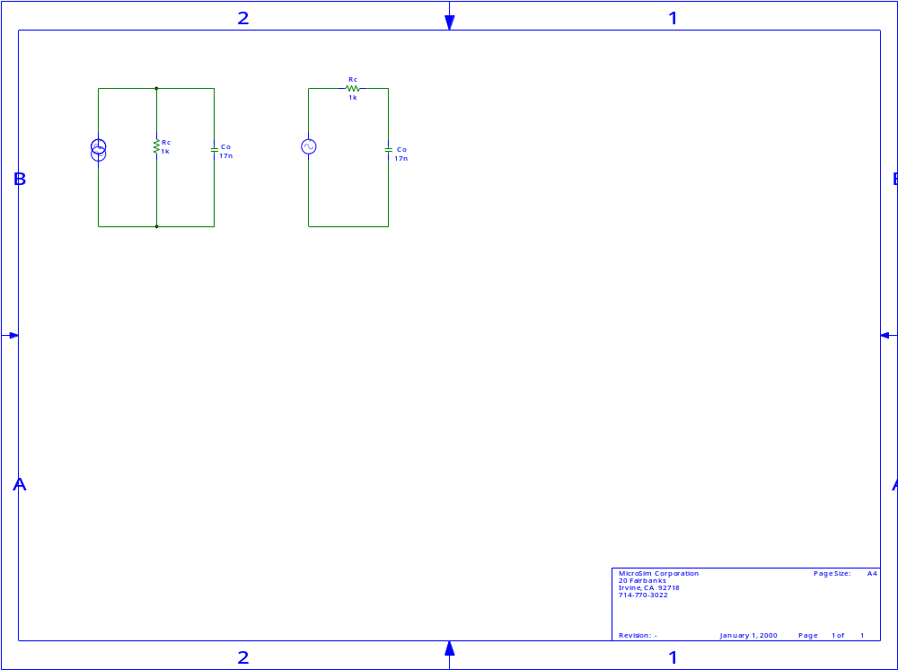

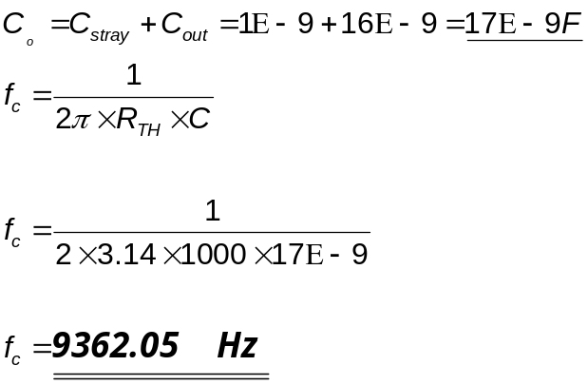

Cut off frequency due to C_{stray}

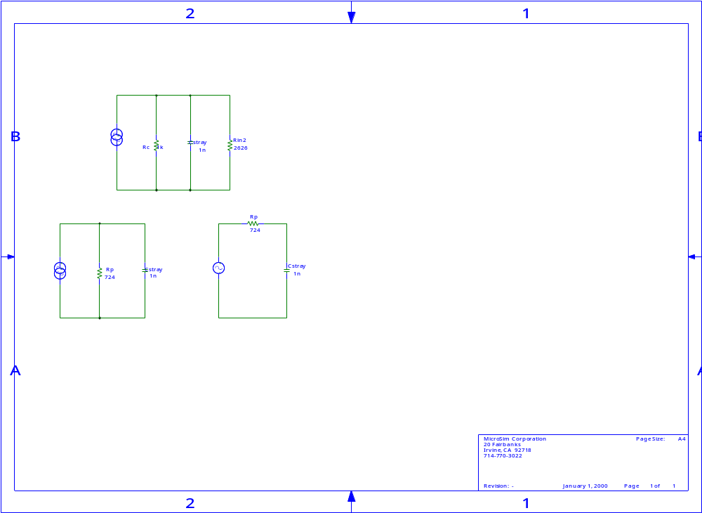

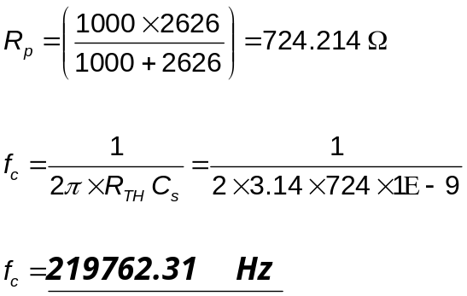

The drop off gain (either side of the –3dB’s cut off frequencies) is a log function, the resulting drop off slope is:-

–6 dB/octave OR
–20dB’s/decade

